1. **Vowel**

1. **Calculator**

**JS & HTML**

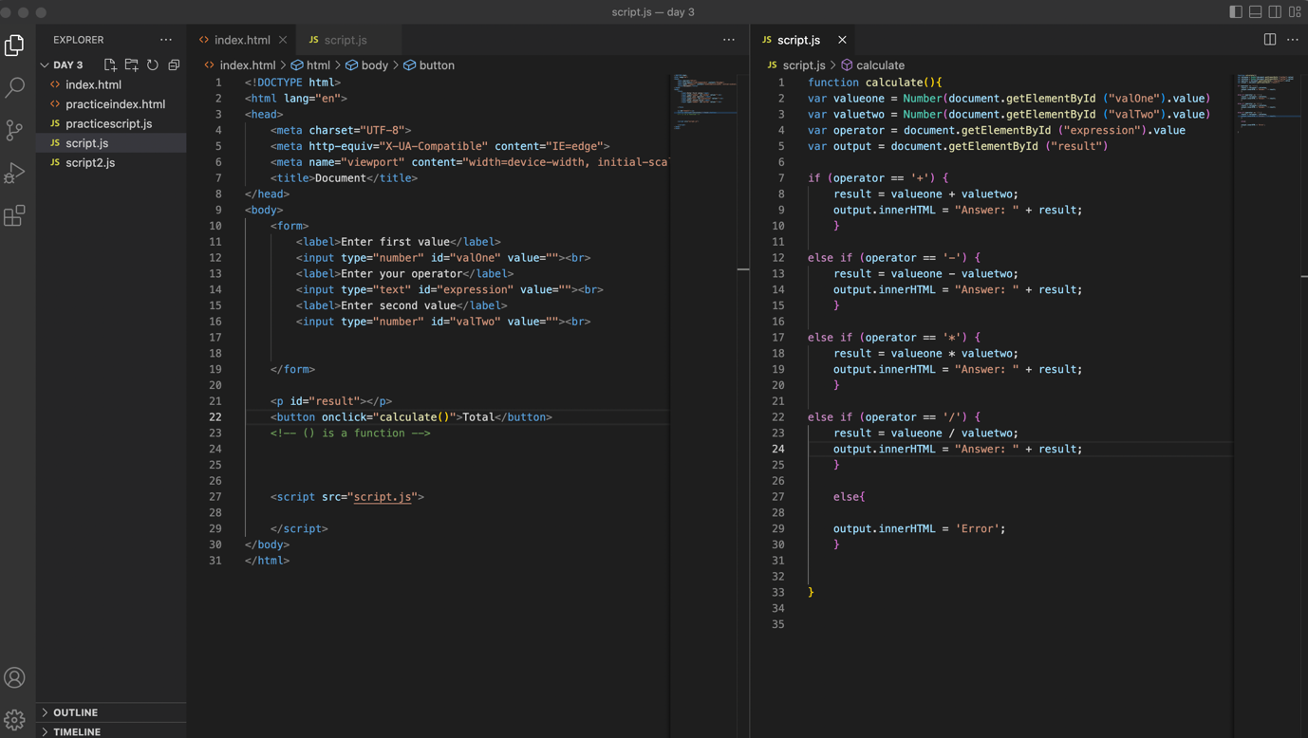

**Output**

1. **Write a JavaScript program to input the sides of a triangle**

**Html & js**

**Output of 3 triangles**

1. **Calculation of Electricity in India**

**HTML & JS**

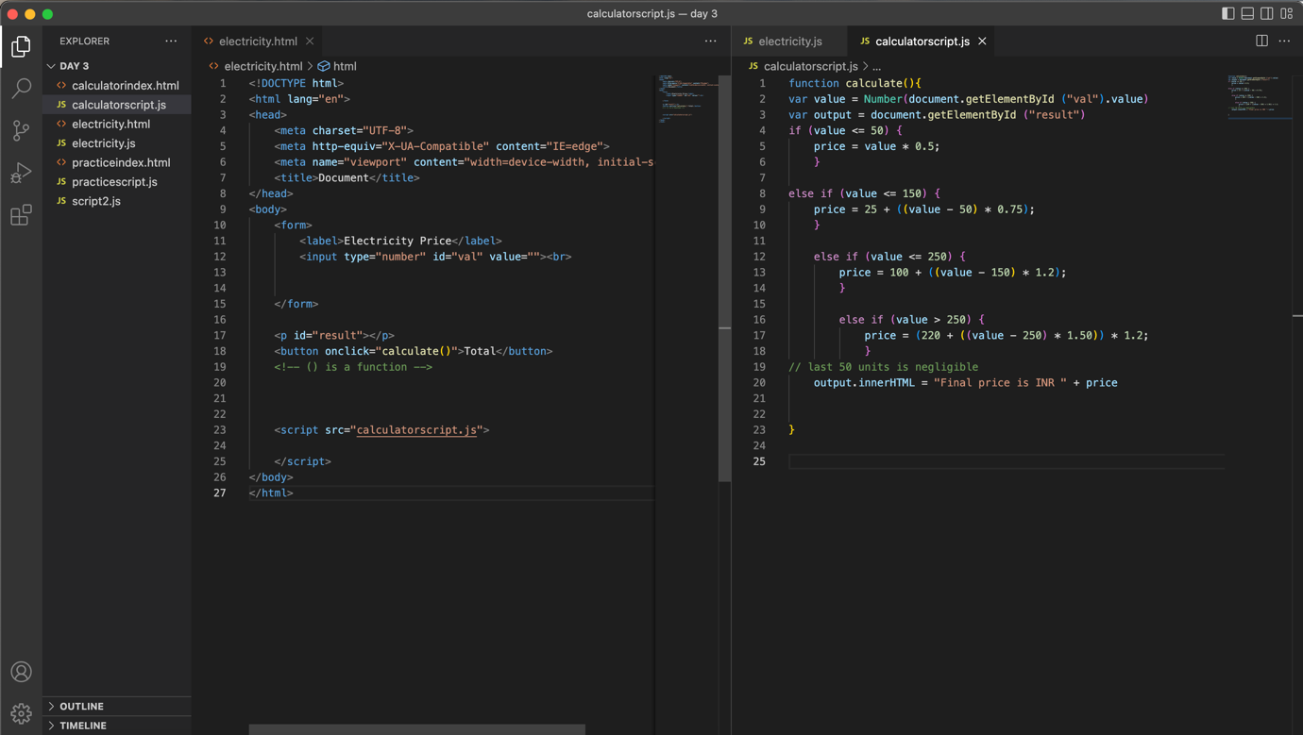

**Output**

1. **Create parameterized method/function to multiply 3 numbers**

function multiply(x, y, z) {

var result = x * y * z;

return result;

}

var r = multiply(2, 3, 4);

console.log(r);

1. **Create parameterized method to divide 2 numbers**

function division(x, y) {

var result = (x, y);

return result;

}

var r = division(6, 3);

console.log(r);

1. **Find the biggest of 3 numbers  (89, 78, 56)**

var arr = [89, 78, 56];

console.log(Math.max(...arr));

1. **Take user input: value is even or odd**

const number = prompt("Enter a number: ");

//check if the number is even

if(number % 2 == 0) {

console.log("The number is even.");

}

// if the number is odd

else {

console.log("The number is odd.");

}

**Output:** (value “4” was inserted in the dialog box)

1. **Take user input: given number is multiple of 3 or not e.g.10900**

const number = prompt("Enter a number: ");

if(number % 3 == 0) {

console.log("The number is multiple of 3.");

}

else {

console.log("The number is not multiple of 3.");

}

**Output:** (value “6” was inserted in the dialogue box)

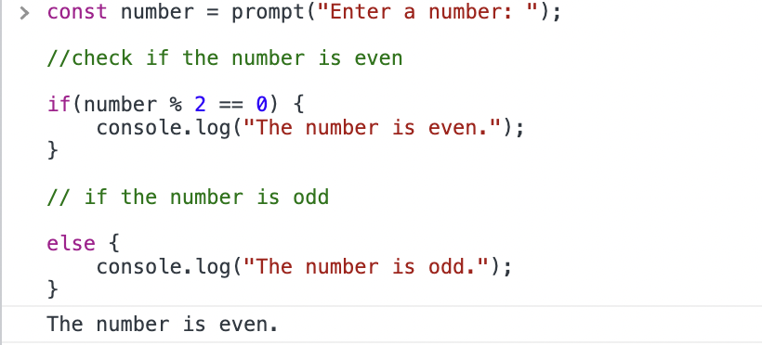

1. **Take user input: calculate simple interest ((p/r * t) * 100 )**

const p = prompt("Enter a number: ");

const r = prompt("Enter a number: ");

const t = prompt("Enter a number: ");

var si = ((p/r * t) * 100 )

console.log(si)

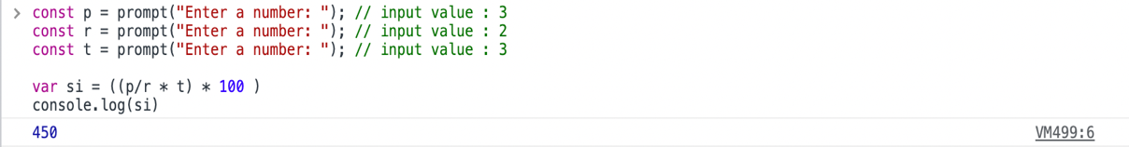

1. **Take user input: 0-6 display day week depending upon what user is entering (0-> Sunday) : using switch**

**HTML & JS**

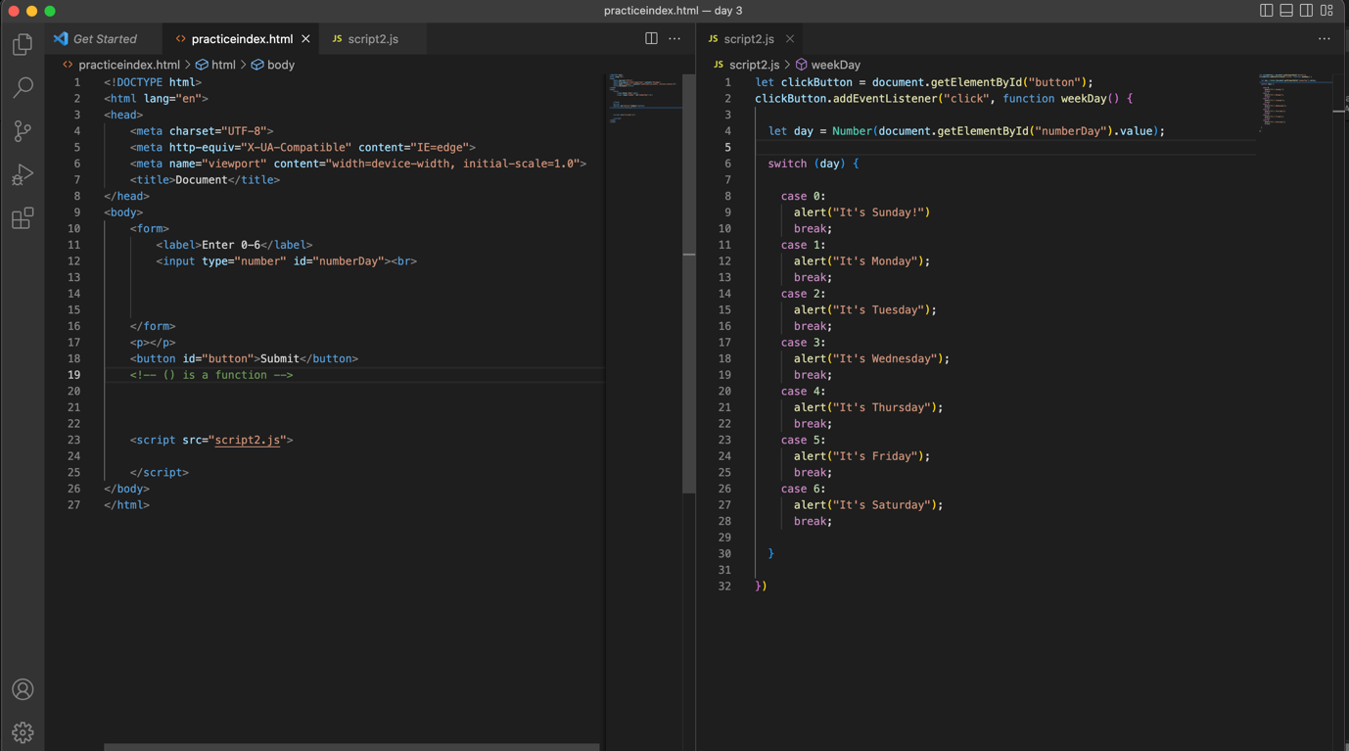

**Output (‘0’ was selected)**

1. **Use loops, and conditional statements, take input from the user**

* ***Multiplication table (ask number from user)***

* ***Sum of digits: e.g. (123: 1 + 2 + 3 = 6) or (1234 : 1 + 2 + 3 + 4 = 10) : hint - loops, divisor and modulus***

* ***Palindrome string***

* ***The display even numbers up to n number***

*Output ( value 8 is entered )*

* ***Count even and odd numbers from 1 to 999***

*Output (even from 1 to 999)*

*Output (odd from 1 to 999)*

* ***Count occurrence of a particular character in a string (hello: count of l is 2)***

* ***Sum and average of array elements [1, 9, 8];***



* ***The largest number in an array (do with loops)***

1. **foo & bar & helloworld display**

**Console Output:**

1. **Using selectors: create a list in HTML: ask the user for any item from the list display 'item' found.**

**HTML & JS**

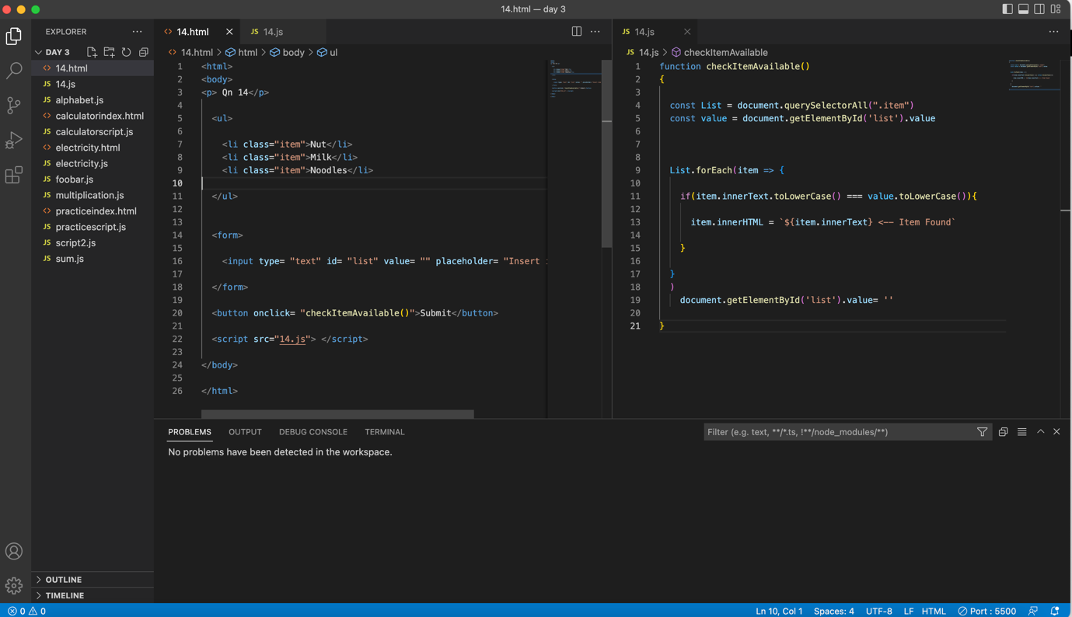

**Output**

